Design for Problem 2 Day 4 (Problem3)
- The program is meant to ask the user for a temperature (in Fahrenheit or Celsius) and identify the state in which the water will be at. Water is a solid at or below 32 degrees F or 0 degrees C, it is a gas at or above 212 degrees F or 100 degrees C, and it is liquid at all temperatures in between.
- Examples
  - If the temperature is 17 degrees F, the water is solid
  - If the temperature is 34 degrees C, the water is liquid
- Pseudocode
tempVariable is set to the input temperature (as a float)
degreesVariable is set to the input Fahrenheit or Celsius (F or C)
if degreesVariable is C then follow the following
if tempVariable is less than or equal to 0
then print “the water is solid”
if tempVariable is greater than 100
then print “the water is gas”
if it’s in between, print that it is a liquid
if degreesVariable is F the follow the following
if tempVariable is less than or equal to 32
then print “the water is solid”
if tempVariable is greater than 212
then print “the water is gas”
if it’s in between, print that it is a liquid
- Variables
  - temp
  - degrees

- Python Statements
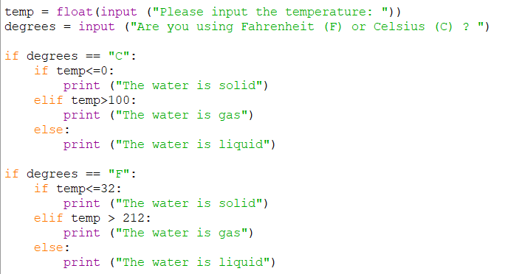
- Inputs and Outputs
  - Input – temp (float) , degrees (string)
  - Output – state of the water
- Python Code (turned in as .py file)

